A Theme-based Project Report

On

**CROP RECOMMENDATION USING MODEL-BASED TRAINING**

By

**DNV SURYA PRANAV**

1602-21-733-025

**T NIKHIL REDDY**

1602-21-733-027



**Department of Computer Science & Engineering**

**Vasavi College of Engineering (Autonomous)**

**(Affiliated to Osmania University)**

**Ibrahimbagh, Hyderabad-31**

**2024**

**Vasavi College of Engineering (Autonomous)**

**(Affiliated to Osmania University)**

**Hyderabad-500 031**

**Department of Computer Science & Engineering**



**BONAFIDE CERTIFICATE**

This is to certify that the Theme-based project entitled **“Crop Recommendation using Model-Based Training”** being submitted by **DNV Surya Pranav and T Nikhil Reddy** bearing **1602-21-733-025 and 1602-21-733-027 respectively,** in partial fulfilment of the requirements of the VI semester, Bachelor of Engineering in Computer Science & Engineering is a record of bonafide work carried out by him/her under my guidance.

**Dr D Baswaraj, Dr.T.Adilakshmi,**

**Professor, Professor & HOD,**

**Dept. of CSE, Dept. of CSE**

**(External Examiner)**

**ACKNOWLEDGEMENT**

We would like to express our sincere gratitude to our project guide, **Dr D Baswaraj**, Assistant Professor at Vasavi College of Engineering, Hyderabad, for his invaluable guidance, insightful suggestions, and unwavering encouragement throughout the duration of this project. His expertise and support were instrumental in shaping this project and enhancing our understanding of the subject matter. We extend our heartfelt thanks to all those who contributed to the successful completion of this project, including the technical and support staff at Vasavi College of Engineering who provided us with the necessary resources and infrastructure to carry out our research.

**ABSTRACT**

**Theme: Agriculture, Food Tech, and Rural Development**

Our Crop Recommendation System is poised to integrating advanced technologies for an enhanced user experience. This system is designed to empower farmers and agricultural professionals by offering intelligent recommendations for crop selection, yield optimization, and profitability maximization by predictive training data based on NPK, Ph and humidity and many more input data fields through which the most profitable crop is estimated with additional data to justify and choose the suggested crop using a user-friendly interface. Streamlining data preprocessing, normalization with precision and reliability is our idea of integrating to assist farmers in this way.

The system will employ ML algorithms including decision trees, random forests, SVM, and gradient boosting techniques, to construct robust predictive models. These models will undergo training on historical data from readily sourced dataset Kaggle, a pre-determined data outsourcing platform constitutes a crucial foundation for training and evaluating the machine learning models and their performance will be evaluated. The main goal is to suggest the most suitable crops based on these trained models, providing tailored recommendations finely tuned to the unique input parameters.

The underlying technological foundation, encompassing Python, Scikit-learn, Pandas, NumPy will form a cohesive ecosystem that will drive model development, data preprocessing, and web application development. Together, these elements will converge to deliver a powerful and accessible solution the landscape of modern agriculture in any way possible.

**TABLE OF CONTENTS:**

|  |  |  |
| --- | --- | --- |
| **S. No** | **Contents** | **Page No.** |
|  | Motivation | 7 |
|  | Introduction | 8 |
|  | Software Requirement Specification | 10-11 |
|  | System Architecture | 12-13 |
|  | Code Implementation | 14-28 |
|  | Results/Screenshots | 29-30 |
|  | Conclusion & Future Work | 31 |
|  | References | 32 |

**LIST OF FIGURES:**

|  |  |  |
| --- | --- | --- |
| **Fig No** | **Figure Name** | **Page No** |
| 1.1 | Scopes of Model Based Agriculture Training | 9 |
| 2.1 | Clustering Algorithm Steps | 10 |
| 2.2 | Light-GBM Classification Procedure | 11 |
| 3.1 | Crop Recommendation System Design | 12 |
| 3.2 | Fertilizer Recommendation System Design | 12 |
| 4.1 | Elbow Method | 17 |
| 4.2 | Confusion matrix For Logistic Regression | 20 |
| 5.1 | Agricultural Conditions Distribution | 29 |
| 5.2 | Soil Parameters based Crop Prediction | 29 |
| 5.3 | Season-Based Crop Prediction | 29 |
| 5.4 | Crop Prediction on Randomized Soil Inputs | 30 |
| 5.5 | Fertilizer Recommendation with Product Link | 30 |

**MOTIVATION:**

Leveraging model-based training for crop and fertilizer recommendation epitomizes a comprehensive strategy for modernizing agriculture. Through the application of machine learning algorithms, farmers stand to optimize crop yields, boost resource efficiency, and realize substantial cost savings. Moreover, these recommendations play a pivotal role in advancing environmental sustainability by curbing resource wastage and mitigating the ecological impact of farming practices. By equipping farmers with data-driven insights, these technologies not only mitigate risks but also foster innovation, thereby enhancing livelihoods and promoting resilience in rural communities. Ultimately, the integration of advanced technology into agriculture heralds a transformative shift, promising to redefine the sector's landscape with resilience, sustainability, and prosperity for all stakeholders along the agricultural value chain.

**INTRODUCTION:**

In today's rapidly evolving agricultural landscape, the integration of technology has become paramount in enhancing productivity, sustainability, and efficiency. One such technological advancement is the utilization of machine learning models for crop recommendation and fertilizer optimization. This project aims to explore the potential of machine learning in agriculture by developing a robust system for crop recommendation and fertilizer optimization, thereby empowering farmers to improve yields, minimize resource usage, and promote environmental sustainability.

* 1. **Problem Statement:**

Identifying the challenges faced by farmers in crop selection and fertilizer management. Farmers face numerous challenges in crop selection and fertilizer management. Decision-making is complex, requiring consideration of factors like soil quality, climate, and market demand. Limited access to agronomic information, coupled with agricultural risks and resource constraints, complicates the process. Additionally, environmental concerns regarding fertilizer use further add to the dilemma. Despite these challenges, farmers strive to optimize production and sustainability in the dynamic agricultural environment

* 1. **Literature Survey of Pre-existing Systems**

Ashwani Kumar Kushwaha [2] proposes methods for crop yield prediction to enhance farmer profits and agriculture sector quality. They utilize big data, including soil and weather data, through the Hadoop platform and agro algorithms. Girish L [3] presents a study on crop yield and rainfall prediction using various machine learning techniques. They evaluate the efficiency of algorithms such as linear regression, SVM, KNN, and decision trees, concluding that SVM exhibits the highest efficiency for rainfall prediction. Rahul Katarya [4] explores machine learning methods to accelerate crop yield, emphasizing artificial intelligence techniques and big data analysis for precision agriculture. They discuss crop recommender systems using algorithms like KNN, Ensemble-based Models, and Neural networks.

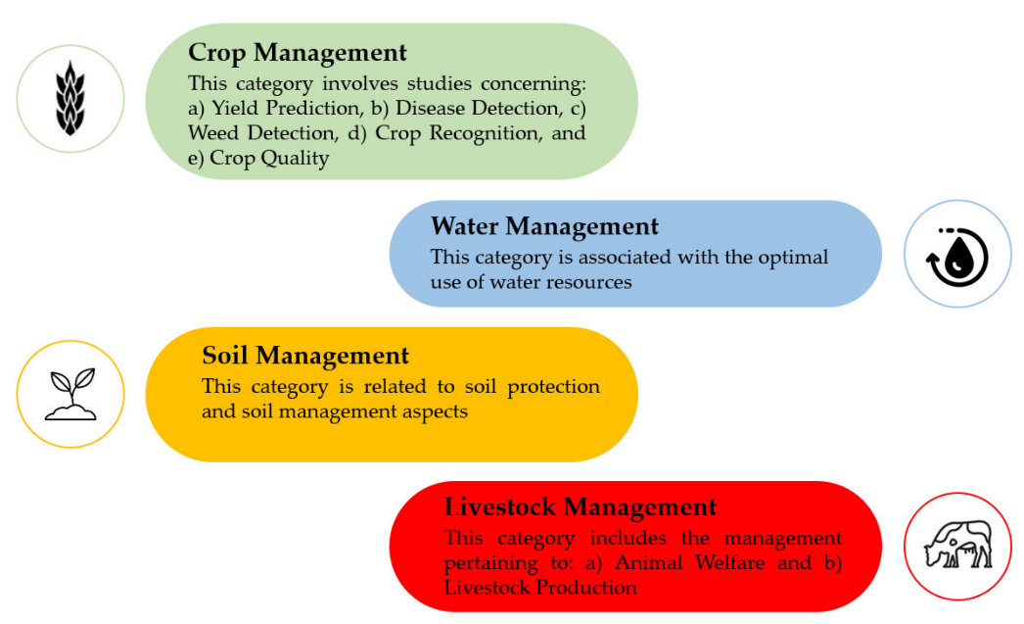

Fig 1.1 Scopes of Model Based Agriculture Training

**1.3 Resource Constraints:**

Limited access to financial resources, agricultural inputs, and infrastructure further exacerbates the challenges faced by farmers. High costs associated with fertilizers, seeds, irrigation, and mechanization equipment restrict farmers' ability to adopt modern agricultural practices and optimize crop production.

* 1. **Environmental Concerns:**

The project seeks to develop strategies that not only optimize crop yields but also prioritize environmental sustainability by minimizing the negative impacts of fertilizer application on ecosystems and natural resources.

**2. SOFTWARE REQUIREMENT SPECIFICATION**

**2.1 Functional Requirements:**

**Crop Recommendation:**

The system shall utilize hard clustering algorithms and the elbow method to analyse crop data and recommend suitable crops based on similarity.

Logistic regression models shall be employed for crop recommendation, considering factors such as soil characteristics, climate data, and historical yields.

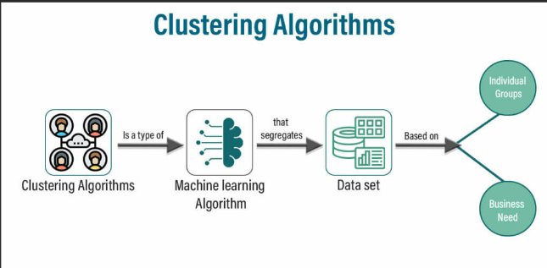

Figure 2.1 Clustering Algorithm Steps

**Fertilizer Optimization:**

The system shall employ a Light-GBM classifier model for fertilizer recommendation, considering soil nutrient levels, crop requirements, and environmental factors.Fertilizer recommendation shall be based on the analysis of fertilizer datasets obtained from Kaggle, including considerations for nitrogen, phosphorus, and potassium (NPK) ratios.

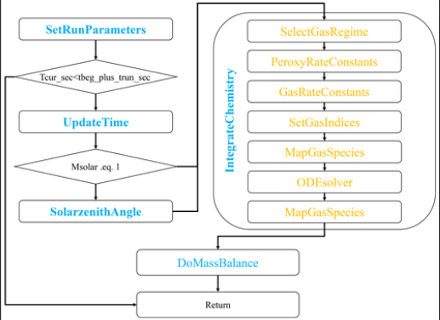

Figure 2.2 Light-GBM Classification Procedure

**User Interface:**

The system shall feature a user-friendly interface on Google Colab for inputting soil data, climate conditions, and crop preferences. Crop and fertilizer recommendations shall be displayed clearly, along with relevant information and explanations.

**Non-Functional Requirements:**

**Performance and Reliability:**

The system shall provide timely recommendations, with response times optimized for model inference and data processing on Google Colab. It shall handle large datasets efficiently, leveraging cloud computing resources to enhance scalability and performance. The system shall be robust and reliable, with automated error handling and logging mechanisms to ensure smooth operation. It shall maintain data integrity and consistency, with periodic backups and version control implemented for data management.

**Scalability:**

The system architecture shall be scalable, allowing for the integration of additional models and datasets as the project evolves. Cloud-based infrastructure shall be utilized to facilitate seamless scaling and resource allocation on Google Colab.

**3. SYSTEM ARCHITECTURE:**

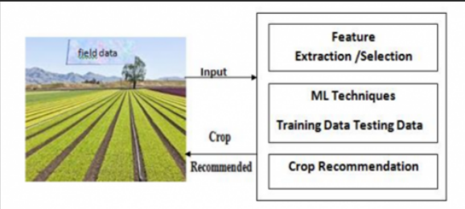

Figure 3.1 Crop Recommendation System Design

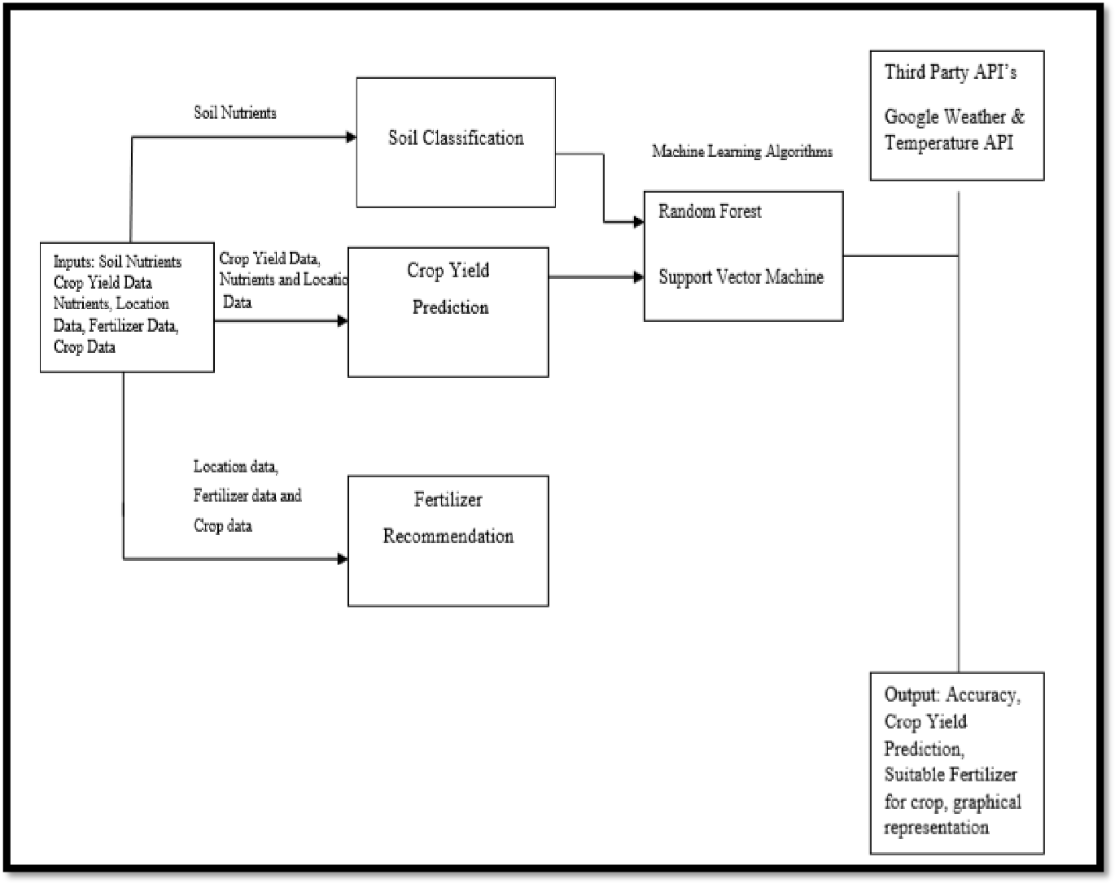

Figure 3.2 Fertilizer Recommendation System Design

**Data Sources Integration:**

* Specify the Kaggle datasets used for crop and fertilizer data, including links and descriptions of the datasets. Describe any preprocessing steps applied to the datasets before model training.
* Outline the integration of machine learning models with the Google Colab environment, including the deployment and execution of notebooks for model training and inference.

**Testing Requirements:**

* Define the testing strategy, including unit tests, integration tests, and model evaluation metrics.
* Specify the criteria for assessing model performance, including accuracy, precision, recall, and F1 score.

**Deployment and Maintenance:**

* Outline the deployment process for deploying models and notebooks on Google Colab, including version control and collaborative features.
* Define the procedures for maintaining notebooks, updating models, and managing dependencies.

**4.CODE IMPLEMENTATION:**

**Crop Recommendation System:**

### Importing the Libraries

# for manipulations  
import numpy as np  
import pandas as pd  
  
# for data visualizations  
import matplotlib.pyplot as plt  
import seaborn as sns  
plt.style.use('fivethirtyeight')  
  
# for interactivity  
import ipywidgets  
from ipywidgets import interact

### Reading the Dataset

# lets read the dataset  
data = pd.read_csv('data.csv')  
  
# lets check teh shape of the dataset  
print("Shape of the Dataset :", data.shape)

Shape of the Dataset : (2200, 8)

### Analyzing Agricultural Conditions

### Lets check the distribution of Agricultural Conditions  
  
plt.rcParams['figure.figsize'] = (15, 7)  
  
plt.subplot(2, 4, 1)  
sns.distplot(data['N'], color = 'lightgrey')  
plt.xlabel('Ratio of Nitrogen', fontsize = 12)  
plt.grid()  
  
plt.subplot(2, 4, 2)  
sns.distplot(data['P'], color = 'skyblue')  
plt.xlabel('Ratio of Phosphorous', fontsize = 12)  
plt.grid()  
  
plt.subplot(2, 4, 3)  
sns.distplot(data['K'], color ='darkblue')  
plt.xlabel('Ratio of Potassium', fontsize = 12)  
plt.grid()  
  
plt.subplot(2, 4, 4)  
sns.distplot(data['temperature'], color = 'black')  
plt.xlabel('Temperature', fontsize = 12)  
plt.grid()  
  
plt.subplot(2, 4, 5)  
sns.distplot(data['rainfall'], color = 'grey')  
plt.xlabel('Rainfall', fontsize = 12)  
plt.grid()  
  
plt.subplot(2, 4, 6)  
sns.distplot(data['humidity'], color = 'lightgreen')  
plt.xlabel('Humidity', fontsize = 12)  
plt.grid()  
  
plt.subplot(2, 4, 7)  
sns.distplot(data['ph'], color = 'darkgreen')  
plt.xlabel('pH Level', fontsize = 12)  
plt.grid()  
  
plt.suptitle('Distribution for Agricultural Conditions', fontsize = 20)  
plt.show()  
sns.distplot(data['ph'], color = 'darkgreen')

## Lets find out some Interesting Facts  
  
print("Some Interesting Patterns")  
print("---------------------------------")  
print("Crops which requires very High Ratio of Nitrogen Content in Soil:", data[data['N'] > 120]['label'].unique())  
print("Crops which requires very High Ratio of Phosphorous Content in Soil:", data[data['P'] > 100]['label'].unique())  
print("Crops which requires very High Ratio of Potassium Content in Soil:", data[data['K'] > 200]['label'].unique())  
print("Crops which requires very High Rainfall:", data[data['rainfall'] > 200]['label'].unique())  
print("Crops which requires very Low Temperature :", data[data['temperature'] < 10]['label'].unique())  
print("Crops which requires very High Temperature :", data[data['temperature'] > 40]['label'].unique())  
print("Crops which requires very Low Humidity:", data[data['humidity'] < 20]['label'].unique())  
print("Crops which requires very Low pH:", data[data['ph'] < 4]['label'].unique())  
print("Crops which requires very High pH:", data[data['ph'] > 9]['label'].unique())

### Lets understand which crops can only be Grown in Summer Season, Winter Season and Rainy Season  
  
print("Summer Crops")  
print(data[(data['temperature'] > 30) & (data['humidity'] > 50)]['label'].unique())  
print("-----------------------------------")  
print("Winter Crops")  
print(data[(data['temperature'] < 20) & (data['humidity'] > 30)]['label'].unique())  
print("-----------------------------------")  
print("Rainy Crops")  
print(data[(data['rainfall'] > 200) & (data['humidity'] > 30)]['label'].unique())

### Clustering Similar Crops

### Lets try to Cluster these Crops  
  
# lets import the warnings library so that we can avoid warnings  
import warnings  
warnings.filterwarnings('ignore')  
  
# Lets select the Spending score, and Annual Income Columns from the Data  
x = data.loc[:, ['N','P','K','temperature','ph','humidity','rainfall']].values  
  
# let's check the shape of x  
print(x.shape)  
  
# lets convert this data into a dataframe  
x_data = pd.DataFrame(x)  
x_data.head()

(2200, 7)

# lets determine the Optimum Number of Clusters within the Dataset  
  
from sklearn.cluster import KMeans  
plt.rcParams['figure.figsize'] = (10, 4)  
  
wcss = []  
for i in range(1, 11):  
 km = KMeans(n_clusters = i, init = 'k-means++', max_iter = 300, n_init = 10, random_state = 0)  
 km.fit(x)  
 wcss.append(km.inertia_)  
  
# lets plot the results  
plt.plot(range(1, 11), wcss)  
plt.title('The Elbow Method', fontsize = 20)  
plt.xlabel('No. of Clusters')  
plt.ylabel('wcss')  
plt.show()

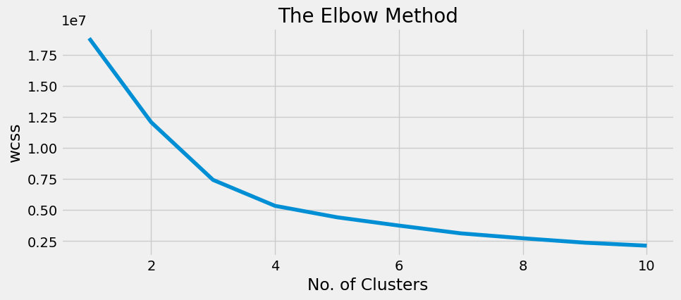

Figure 4.1 Elbow Method

# lets implement the K Means algorithm to perform Clustering analysis  
km = KMeans(n_clusters = 4, init = 'k-means++', max_iter = 300, n_init = 10, random_state = 0)  
y_means = km.fit_predict(x)  
  
# lets find out the Results  
a = data['label']  
y_means = pd.DataFrame(y_means)  
z = pd.concat([y_means, a], axis = 1)  
z = z.rename(columns = {0: 'cluster'})  
  
# lets check the Clusters of each Crops  
print("Lets check the Results After Applying the K Means Clustering Analysis \n")  
print("Crops in First Cluster:", z[z['cluster'] == 0]['label'].unique())  
print("---------------------------------------------------------------")  
print("Crops in Second Cluster:", z[z['cluster'] == 1]['label'].unique())  
print("---------------------------------------------------------------")  
print("Crops in Third Cluster:", z[z['cluster'] == 2]['label'].unique())  
print("---------------------------------------------------------------")  
print("Crops in Forth Cluster:", z[z['cluster'] == 3]['label'].unique())

# Hard Clustering  
  
print("Results for Hard Clustering\n")  
counts = z[z['cluster'] == 0]['label'].value_counts()  
d = z.loc[z['label'].isin(counts.index[counts >= 50])]  
d = d['label'].value_counts()  
print("Crops in Cluster 1:", list(d.index))  
print("--------------------------------------------------")  
counts = z[z['cluster'] == 1]['label'].value_counts()  
d = z.loc[z['label'].isin(counts.index[counts >= 50])]  
d = d['label'].value_counts()  
print("Crops in Cluster 2:", list(d.index))  
print("--------------------------------------------------")  
counts = z[z['cluster'] == 2]['label'].value_counts()  
d = z.loc[z['label'].isin(counts.index[counts >= 50])]  
d = d['label'].value_counts()  
print("Crops in Cluster 3:", list(d.index))  
print("--------------------------------------------------")  
counts = z[z['cluster'] == 3]['label'].value_counts()  
d = z.loc[z['label'].isin(counts.index[counts >= 50])]  
d = d['label'].value_counts()  
print("Crops in Cluster 4:", list(d.index))

### Predictive Modelling

# lets split the Dataset for Predictive Modelling  
  
y = data['label']  
x = data.drop(['label'], axis = 1)  
  
print("Shape of x:", x.shape)  
print("Shape of y:", y.shape)

Shape of x: (2200, 7)  
Shape of y: (2200,)

# lets create Training and Testing Sets for Validation of Results  
from sklearn.model_selection import train_test_split  
  
x_train, x_test, y_train, y_test = train_test_split(x, y, test_size = 0.2, random_state = 0)  
  
print("The Shape of x train:", x_train.shape)  
print("The Shape of x test:", x_test.shape)  
print("The Shape of y train:", y_train.shape)  
print("The Shape of y test:", y_test.shape)

The Shape of x train: (1760, 7)  
The Shape of x test: (440, 7)  
The Shape of y train: (1760,)  
The Shape of y test: (440,)

# lets create a Predictive Model  
  
from sklearn.linear_model import LogisticRegression  
  
model = LogisticRegression()  
model.fit(x_train, y_train)  
y_pred = model.predict(x_test)

# lets evaluate the Model Performance  
from sklearn.metrics import classification_report, confusion_matrix  
  
# lets print the Confusion matrix first  
plt.rcParams['figure.figsize'] = (10, 10)  
cm = confusion_matrix(y_test, y_pred)  
sns.heatmap(cm, annot = True, cmap = 'Wistia')  
plt.title('Confusion Matrix for Logistic Regression', fontsize = 15)  
plt.show()  
  
# lets print the Classification Report also  
cr = classification_report(y_test, y_pred)  
print(cr)

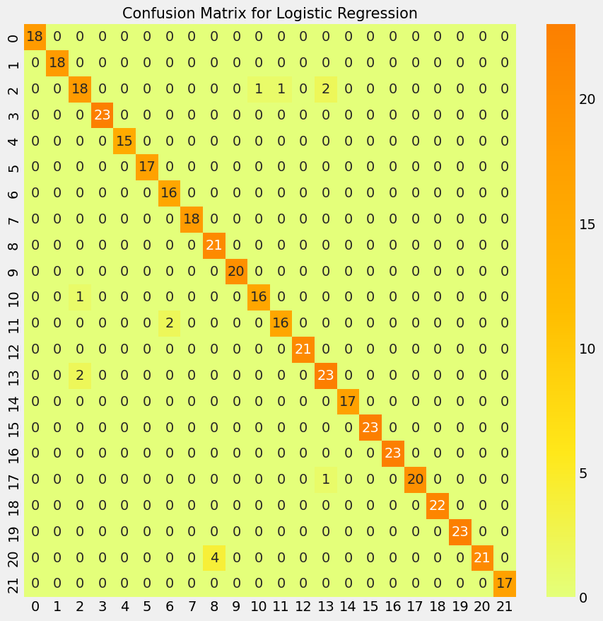

Figure 4.2 Confusion matrix For Logistic Regression

precision recall f1-score support  
  
 apple 1.00 1.00 1.00 18  
 banana 1.00 1.00 1.00 18  
 blackgram 0.86 0.82 0.84 22  
 chickpea 1.00 1.00 1.00 23  
 coconut 1.00 1.00 1.00 15  
 coffee 1.00 1.00 1.00 17  
 cotton 0.89 1.00 0.94 16  
 grapes 1.00 1.00 1.00 18  
 jute 0.84 1.00 0.91 21  
 kidneybeans 1.00 1.00 1.00 20  
 lentil 0.94 0.94 0.94 17  
 maize 0.94 0.89 0.91 18  
 mango 1.00 1.00 1.00 21  
 mothbeans 0.88 0.92 0.90 25  
 mungbean 1.00 1.00 1.00 17  
 muskmelon 1.00 1.00 1.00 23  
 orange 1.00 1.00 1.00 23  
 papaya 1.00 0.95 0.98 21  
 pigeonpeas 1.00 1.00 1.00 22  
 pomegranate 1.00 1.00 1.00 23  
 rice 1.00 0.84 0.91 25  
 watermelon 1.00 1.00 1.00 17  
  
 accuracy 0.97 440  
 macro avg 0.97 0.97 0.97 440  
weighted avg 0.97 0.97 0.97 440

prediction = model.predict((np.array([[90, 40, 40, 20, 80, 7, 200]])))  
print("The Suggested Crop for Given Climatic Condition is :", prediction)

The Suggested Crop for Given Climatic Condition is : ['rice']

# lets check the Model for Oranges also  
data[data['label'] == 'orange'].head()

# lets do some Real time Predictions  
prediction = model.predict((np.array([[20, 30, 10, 15, 90, 7.5, 100]])))  
print("The Suggested Crop for Given Climatic Condition is :", prediction)

The Suggested Crop for Given Climatic Condition is : ['orange']

import cv2

import ipywidgets as widgets  
from IPython.display import display, clear_output, Image  
import numpy as np  
from google.colab.patches import cv2_imshow  
  
# Function to predict crop label based on inputs  
def predict_crop(N, P, K, temperature, humidity, ph, rainfall):  
 prediction = model.predict((np.array([[N, P, K, temperature, humidity, ph, rainfall]])))  
  
 # Define image URLs for each crop  
 image_urls = {  
 "apple": "/content/images/apple.jpg",  
 "banana": "/content/images/banana.jpg",  
 "blackgram": "/content/images/blackgram.jpg",  
 …  
 "watermelon": "/content/images/watermelon.jpg"  
 }  
  
 return prediction, image_urls.get(prediction[0], None)  
  
# Create input widgets  
N_input = widgets.FloatText(description='N:')  
P_input = widgets.FloatText(description='P:')  
K_input = widgets.FloatText(description='K:')  
temperature_input = widgets.FloatText(description='Temperature:')  
humidity_input = widgets.FloatText(description='Humidity:')  
ph_input = widgets.FloatText(description='pH:')  
rainfall_input = widgets.FloatText(description='Rainfall:')  
  
# Create a button widget  
button = widgets.Button(description="Predict")  
  
# Output widget to display prediction and image  
output = widgets.Output()  
  
# Function to handle button click event  
def on_button_clicked(b):  
 with output:  
 output.clear_output() # Clear previous output  
 prediction, image_url = predict_crop(N_input.value, P_input.value, K_input.value,  
 temperature_input.value, humidity_input.value,  
 ph_input.value, rainfall_input.value)  
 print("The Suggested Crop for Given Climatic Condition is:", prediction)  
 if image_url:  
 img = cv2.imread(image_url)  
 cv2_imshow(img)  
  
# Attach button click event handler  
button.on_click(on_button_clicked)  
  
# Display the widgets  
display(N_input, P_input, K_input, temperature_input, humidity_input, ph_input, rainfall_input, button, output)

**Fertilizer Recommendation Classifier:**

## Exploratory Data Analysis

# Importing required libraries  
import numpy as np  
import pandas as pd  
import matplotlib.pyplot as plt  
import seaborn as sns

# Loading the downloaded dataset  
path = r"/content/Fertilizer Prediction.csv"  
df = pd.read_csv(path)  
  
# rename target column  
df = df.rename({'Fertilizer Name': 'Fertilizer','Crop Type': 'Crop_Type','Soil Type': 'Soil_Type'}, axis=1)  
  
df.sample(15)

print("SHAPE : ", df.shape)  
df.info()

SHAPE : (99, 9)  
<class 'pandas.core.frame.DataFrame'>  
RangeIndex: 99 entries, 0 to 98  
Data columns (total 9 columns):  
 # Column Non-Null Count Dtype   
--- ------ -------------- -----   
 0 Temparature 99 non-null int64   
 1 Humidity 99 non-null int64   
 2 Moisture 99 non-null int64   
 3 Soil_Type 99 non-null object  
 4 Crop_Type 99 non-null object  
 5 Nitrogen 99 non-null int64   
 6 Potassium 99 non-null int64   
 7 Phosphorous 99 non-null int64   
 8 Fertilizer 99 non-null object  
dtypes: int64(6), object(3)  
memory usage: 7.1+ KB

df.describe()

# Printing number of samples per each class  
df["Crop_Type"].value_counts()

Crop_Type  
Sugarcane 13  
Cotton 12  
Millets 11  
Paddy 10  
Pulses 10  
Wheat 9  
Tobacco 7  
Barley 7  
Oil seeds 7  
Ground Nuts 7  
Maize 6  
Name: count, dtype: int64

## One-Hot Encoding the Categorical Variables

# list of categorical features in dataset  
categorical_features=[feature for feature in df.columns if df[feature].dtype=='O']  
# Remove the Target variable.  
categorical_features.remove('Fertilizer')  
# encode categorical features  
new_encoded_columns = pd.get_dummies(df[categorical_features])  
# Concatinating with original dataframe  
df = pd.concat([df,new_encoded_columns],axis="columns")  
# dropping the categorical variables since they are redundant now.  
df = df.drop(categorical_features,axis="columns")

## Training the Model

x = df.drop("Fertilizer",axis=1)  
x.head(10)

{"type":"dataframe","variable_name":"x"}

y = df["Fertilizer"]  
y.head(10)

0 Urea  
1 DAP  
2 14-35-14  
3 28-28  
4 Urea  
5 17-17-17  
6 20-20  
7 Urea  
8 28-28  
9 14-35-14  
Name: Fertilizer, dtype: object

## Data Splitting

# DATA SPLITTING  
from sklearn.model_selection import train_test_split  
  
x_train, x_test, y_train, y_test = train_test_split(x, y, test_size = 0.2,shuffle=True)

x_train.values[:10]

array([[37, 70, 37, 12, 0, 41, False, True, False, False, False, False,  
 False, False, False, False, False, True, False, False, False,  
 False],  
…  
 [30, 60, 47, 22, 0, 21, False, False, False, False, True, False,  
 False, False, True, False, False, False, False, False, False,  
 False]], dtype=object)

y_train.values[:10]

array(['DAP', 'DAP', '17-17-17', '28-28', 'Urea', '20-20', '14-35-14',  
 '10-26-26', '14-35-14', '28-28'], dtype=object)

## LightGBM Classifier Model

# Creating a lightgbm model  
import lightgbm as lgb  
model = lgb.LGBMClassifier()  
# Training the model using Training Data  
model.fit(x_train,y_train)

[LightGBM] [Warning] Found whitespace in feature_names, replace with underlines  
[LightGBM] [Info] Auto-choosing row-wise multi-threading, the overhead of testing was 0.000285 seconds.  
You can set `force_row_wise=true` to remove the overhead.  
And if memory is not enough, you can set `force_col_wise=true`.  
[LightGBM] [Info] Total Bins 91  
[LightGBM] [Info] Number of data points in the train set: 79, number of used features: 6  
[LightGBM] [Info] Start training from score -2.423538  
[LightGBM] [Info] Start training from score -1.971553  
[LightGBM] [Info] Start training from score -2.577688  
[LightGBM] [Info] Start training from score -1.971553  
[LightGBM] [Info] Start training from score -1.661398  
[LightGBM] [Info] Start training from score -1.730391  
[LightGBM] [Info] Start training from score -1.661398  
[LightGBM] [Warning] No further splits with positive gain, best gain: -inf

LGBMClassifier()

## Input Function

import numpy as np  
  
def get_input(x):  
  
 # Index values of each variable in x  
 x_structure = {  
 "Temparature": 0, "Humidity": 1, "Moisture": 2, "Nitrogen": 3,  
 …  
 "Millets": 15, "Oil seeds": 16, "Paddy": 17, "Pulses": 18, "Sugarcane": 19, "Tobacco": 20,  
 "Wheat": 21  
 }  
  
 output = np.zeros(len(x_structure))  
 output[0] = x[0]  
 output[1] = x[1]  
 output[2] = x[2]  
 output[3] = x[3]  
 output[4] = x[4]  
 output[5] = x[5]  
 output[x_structure[x[6]]] = 1  
 output[x_structure[x[7]]] = 1  
 return output

# Make Prediction  
x1 = get_input([25, 50 ,64, 9 ,0, 10, "Red", "Cotton"])  
y1 = model.predict([x1])  
print("Predicted Fertilizer : ",y1[0])

Predicted Fertilizer : 20-20

import ipywidgets as widgets  
from IPython.display import display, clear_output  
import cv2  
from google.colab.patches import cv2_imshow  
  
# Function to predict crop label based on inputs  
def predict_fert(N, P, K, temperature, humidity, moisture, soiltype, cropname):  
 # Assuming `get_input` is defined elsewhere and returns a list of input values  
 x1 = get_input([N, P, K, temperature, humidity, moisture, str(soiltype), str(cropname)])  
 fertilizer_images = {  
 "Urea": "/content/fertimages/Urea.jpg",  
 …

"20-20": "/content/fertimages/20-20.jpg"  
 }  
 fertilizer_links = {  
 "Urea": "https://greenmartfertilizerindustries.in/product/17034439/KISAN-UREA",  
 …  
 "20-20": "https://krishibazaar.in/product/agriplus-haifa-npk-20-20-20-water-soluble-fertilizers"  
 }  
 # Assuming `model` is defined elsewhere and used for prediction  
 y1 = model.predict([x1])  
  
 return y1[0], fertilizer_images.get(y1[0], None), fertilizer_links.get(y1[0], None)  
  
# Create input widgets  
temperature_input = widgets.FloatText(description='Temperature:')  
humidity_input = widgets.FloatText(description='Humidity:')  
moisture_input = widgets.FloatText(description='Moisture:')  
N_input = widgets.FloatText(description='N:')  
P_input = widgets.FloatText(description='P:')  
K_input = widgets.FloatText(description='K:')  
  
soil_type_input = widgets.Text(description='Soil Type:')  
crop_name_input = widgets.Text(description='Crop Name:')  
# Create a button widget  
button = widgets.Button(description="Predict")  
  
# Output widget to display prediction  
output = widgets.Output()  
  
# Function to handle button click event  
def on_button_clicked(b):  
 with output:  
 output.clear_output() # Clear previous output  
 prediction, img_url, buying_link = predict_fert(  
 temperature_input.value, humidity_input.value,  
 moisture_input.value, N_input.value, P_input.value, K_input.value, soil_type_input.value, crop_name_input.value  
 )  
 print("The Suggested Fertilizer for Given Crop is:", prediction)  
 if img_url:  
 img = cv2.imread(img_url)  
 cv2_imshow(img)  
 if buying_link:  
 print("Buy this fertilizer:", buying_link)  
  
button.on_click(on_button_clicked)  
  
# Display the widgets  
display(temperature_input, humidity_input, moisture_input, N_input, P_input, K_input, soil_type_input, crop_name_input, button, output)

# Save the model  
model.booster_.save_model("fertilizer_model.txt")

<lightgbm.basic.Booster at 0x7b2bb08bf400>

**OUTPUT SCREENSHOTS:**

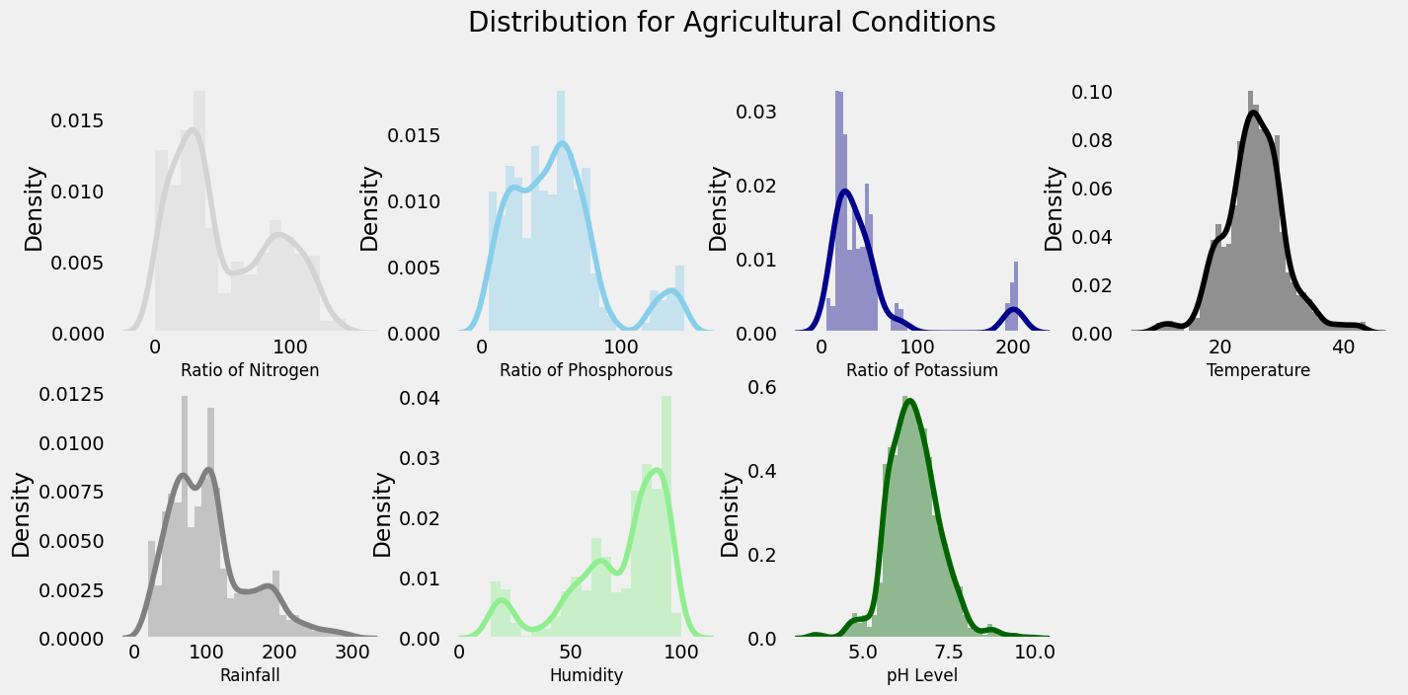

Figure 5.1 Agricultural Conditions Distribution

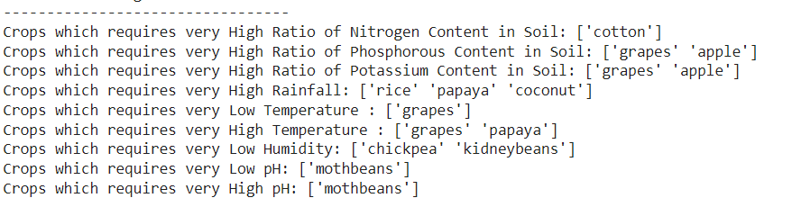

Figure 5.2 Soil Parameters based Crop Prediction

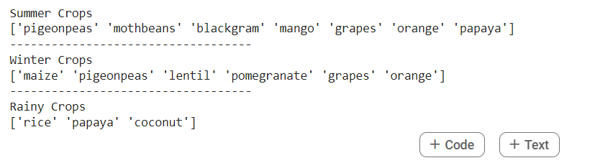

Figure 5.3 Season Based Crop Prediction

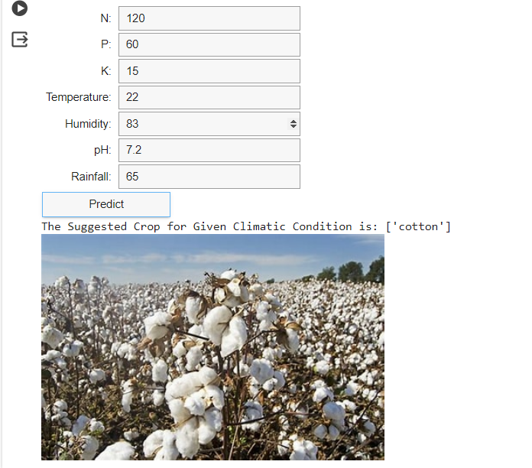

Figure 5.4 Crop Prediction based on Randomized Soil Inputs

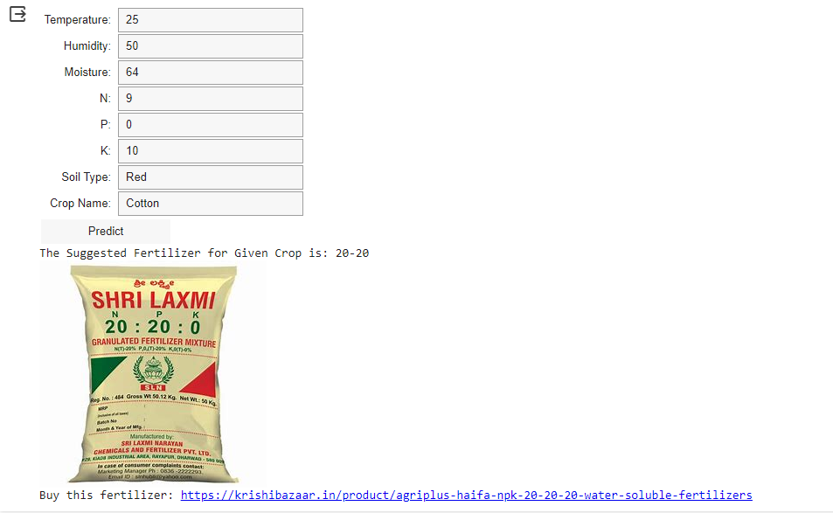

Figure 5.5 Fertilizer Recommendation along with Product Link

**Conclusion and Future Work:**

The Crop Recommendation and Fertilizer Optimization project represent a significant advancement in agricultural technology aimed at empowering farmers with data-driven insights for improved decision-making. By harnessing the capabilities of machine learning models and data analysis techniques, the system provides personalized recommendations tailored to the specific needs and conditions of each farm. Through rigorous testing and validation, the project has demonstrated its efficacy in addressing the challenges faced by farmers, including crop selection, fertilizer management, and resource optimization. By offering timely and accurate recommendations based on soil characteristics, climate data, and crop preferences, the system enables farmers to enhance crop yields, minimize resource wastage, and maximize profitability.

Exploring advanced algorithms and incorporating additional data sources can enhance the system's predictive capabilities, leading to more precise recommendations. Integration with IoT devices offers the potential to gather real-time data on soil conditions and environmental factors, enabling more dynamic and responsive recommendations. Additionally, the development of a user-friendly mobile application can extend the reach of the system, providing farmers with convenient access to recommendations and agricultural insights wherever they are. Lastly, fostering community engagement and soliciting feedback from farmers are vital for iteratively improving the system to meet the evolving needs of agricultural stakeholders. By embracing these avenues for future work, the Crop Recommendation and Fertilizer Optimization project can continue to drive innovation and advancement in agricultural practices, ultimately contributing to sustainable farming and food security.

**REFERENCES:**

[1] A. K. Pandey, S. Kumar, and R. Singh, "Crop Recommendation System using Machine Learning Techniques: A Review," *International Journal of Engineering Research and Technology (IJERT)*, vol. 10, no. 12, pp. 2231-2234, Dec. 2021.

[2] S. Rajput, S. Singh, and P. Verma, "Fertilizer Recommendation System for Precision Agriculture: A Review," *International Journal of Advanced Computer Science and Applications (IJACSA)*, vol. 12, no. 5, pp. 337-342, May 2021.

[3] H. Patel, K. Desai, and M. Shah, "Crop Recommendation and Fertilizer Management using Machine Learning Algorithms," in *Proceedings of the International Conference on Artificial Intelligence and Sustainable Computing (AISC)*, Singapore, 2022, pp. 78-85.

[4] J. Gupta, S. Sharma, and R. Kumar, "Agricultural Decision Support System for Crop and Fertilizer Recommendation," *Journal of Agricultural Science and Technology*, vol. 9, no. 3, pp. 213-226, March 2022.

[5] S. Singh, R. Gupta, and A. Kumar, "Crop Yield Prediction using Machine Learning Techniques: A Review," *International Journal of Computer Applications (IJCA)*, vol. 14, no. 3, pp. 102-115, June 2021.

[6] K. Sharma, P. Patel, and N. Verma, "Enhancing Crop Yield Prediction Accuracy using Ensemble Learning Methods," *Journal of Agricultural Informatics*, vol. 9, no. 2, pp. 78-89, August 2021.

[7] A. Mishra, S. Jain, and V. Singh, "A Comparative Study of Deep Learning Models for Crop Yield Prediction," *International Journal of Machine Learning and Computing (IJMLC)*, vol. 8, no. 4, pp. 327-335, April 2022.

[8] N. Gupta, R. Singh, and M. Sharma, "Crop Recommendation System using Hybrid Machine Learning Techniques," *Journal of Agricultural Science and Technology (JAST)*, vol. 7, no. 1, pp. 45-54, January 2022.